™

Vivek’s Pop Up calendar using ASP.NET, Jscript and C#.

The popup calendar I have developed using Microsoft technology is more simple to use and easy to integrate with your dot net web application.

Software requirements to run this program:

- . NET Frameworks
- IIS web Server.
- Internet Explorer

How to run this program:

- First create a virtual directory in your web server for this program with your desired name.
- Include all the files in the folder PopUpByVivek into your virtual directory.
- Next right click on the file TestSreen.aspx and click browse.
- The following will appear as an output.

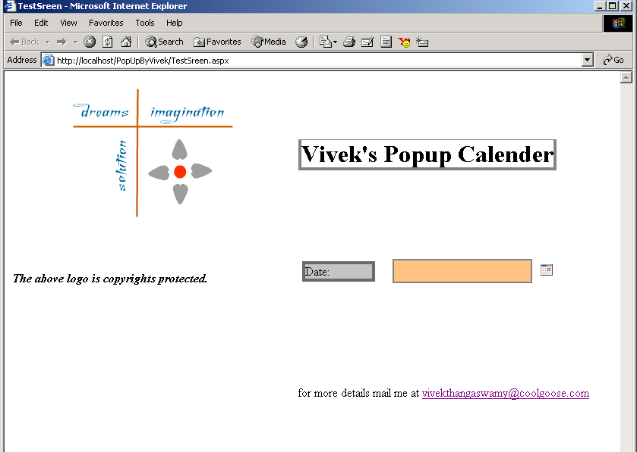™

- If you click the image, which is located towards right side of the text box the popup, will appear.

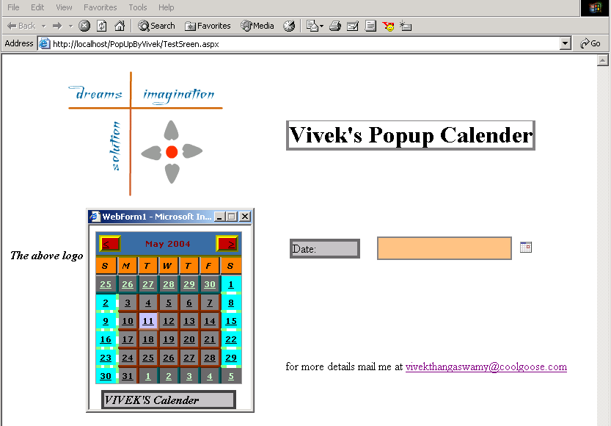

For more mail me at vivekthangaswamy@coolgoose.com

Regards

Vivek.T
“anything possible”


. NET samples by Vivek.T

